**UNIVERSIDAD DE LAS FUERZAS ARMADAS – ESPE**

**CAREER**

**SOFTWARE ENGINEERING**

**SUBJECT**

**FUNDAMENTALS OF ENGINEERING**

**Team 03 Gamers**

**Topic: Mobility in the Quito’s Subway**

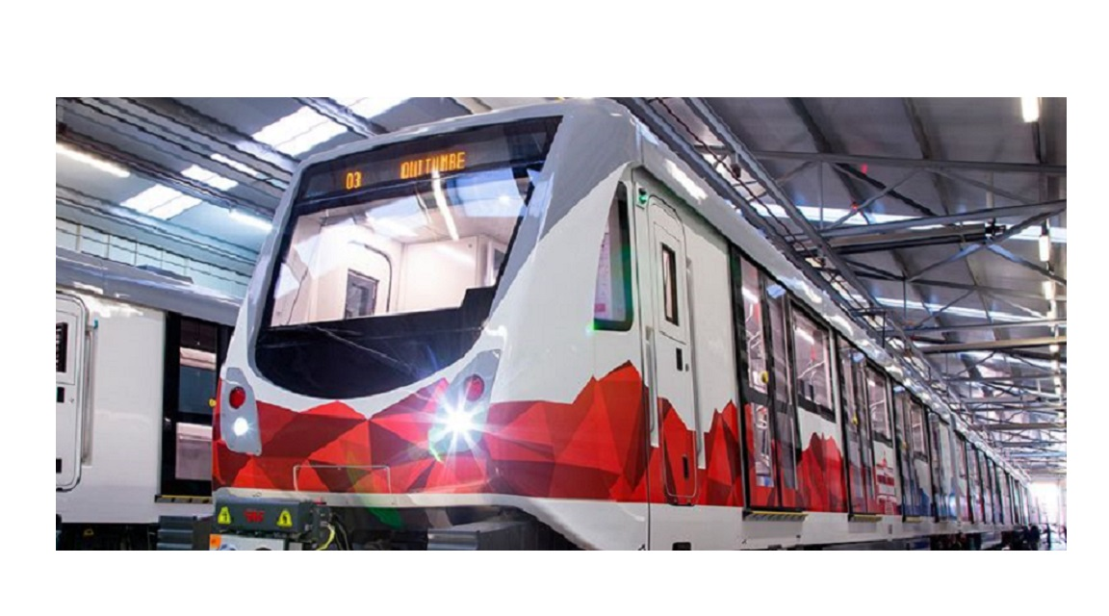

**Integrant**

**MASAPANTA GUILCATOMA JEFFERSON SANTIAGO**

**MIDEROS CRUZ SAMIR ESTEBAN**

**MOLINA GUAICO GUSTAVO STIVEN**

**MORALES SOSA JEIMY MARLEY**

**ORRICO EMME CAMILO ANDRES**

**System for the Metro of Quito**

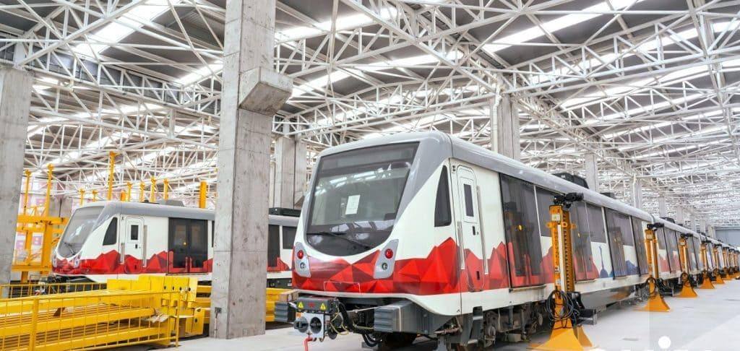

|  |  |  |  |
| --- | --- | --- | --- |
| **Date** | **Review** | **Author** | **Verified Quality Dept.** |
| 10/12/2021 | 1.1 | Masapanta Jeferson  Molina Gustavo  Mideros Samir  Morales Jeimy  Orrico Camilo |  |
| 04/01/2022 | 1.2 | Masapanta Jeferson  Molina Gustavo  Mideros Samir  Morales Jeimy  Orrico Camilo |  |
| 23/02/2022 | 1.3 | Masapanta Jeferson  Molina Gustavo  Mideros Samir  Morales Jeimy  Orrico Camilo |  |

Contenido

1. Introduction 2

1.1 Purpose 2

1.2 Document Conventions 2

1.3 Intended Audience and Reading Suggestions 2

1.4 Product Scope 2

1.5 References 2

2. Overall Description 3

2.1 Product Perspective 3

2.2 Product Functions 3

2.3 User Classes and Characteristics 3

2.4 Operating Environment 3

2.5 Design and Implementation Constraints 3

2.6 Assumptions and Dependencies 4

3. External Interface Requirements 4

3.1 User Interfaces 4

3.2 Hardware Interfaces 4

3.3 Communications Interfaces 4

4. System Features 5

4.1 System Feature 1 5

5. Other Nonfunctional Requirements 15

5.1 Performance Requirements 15

5.2 Safety Requirements 15

5.3 Software Quality Attributes 15

1. Introduction

This archive could be a Software Requirements Specification (SRS) for the stock control administration program for a Research facility. This detail has been organized based on the rules given by the IEEE Suggested Hone for Computer program Necessities Determinations ANSI / IEEE 830, 1998.

**1.1 Purpose**

The purpose of this document is to define the specifications of the app, it should be noted that it will be an application for mobile phones, and will serve for better administration in Quito’s Subway.

**1.2 Document Conventions**

In the Quito metro software, each requirement that the user gave us is an essential contribution to make it easier and safer for the user to use the Quito metro and make an order system for the metro authorities.

**1.3 Intended Audience and Reading Suggestions**

This document is intended for the council in charge of the administration of the Quito metro and its main authorities.

**1.4 Product Scope**

The software's main purpose is to help the user in everything that corresponds to the Quito metro, such as buying tickets through a cell phone application, also knowing the arrival times of each car, this will help to avoid loss standby time. It will also provide greater security for users through an emergency button in case of robbery, violence, etc.

And finally, it will provide statistics of users who make use of the Quito subway at each station for greater control or for future improvements. [1]

**1.5 References**

[1] «Inicio», *Metro de Quito*. https://metrodequito.gob.ec/ (accedido dic. 09, 2021).

2. Overall Description

**2.1 Product Perspective**

The application is for use by the municipality of Quito, for the control of the Quito subway, the component that will control the entire system is a database that is linked to the civil registry and banking entities.

**2.2 Product Functions**

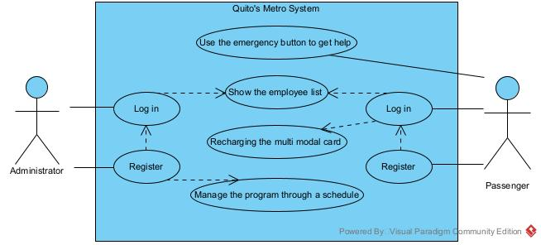

**2.3 User Classes and Characteristics**

The passengers who use our application are all the people who are going to use the Quito subway as a means of transportation to go to a destination.

The administrator of the application will include the schedule of the Metro, and this administrator can see how many people arrive and leave the station per day.

**2.4 Operating Environment**

The software will basically operate on digital devices with operating systems such as android and IOS in various versions.

**2.5 Design and Implementation Constraints**

The biggest restriction we have is that the metropolitan district of Quito does not have a clear administration of the operation of the Quito metro, such as the operating hours and the cost of the passage. Another restriction is that we need the database of the civil registry for the purchase of tickets with the ID.

**2.6 Assumptions and Dependencies**

* The requirements described are assumed to be stable and can be accomplished.
* The devices on which the app will work satisfy the minimum requirements to guarantee their respective execution.
* It’s assumed that users have experience with similar apps.

3. External Interface Requirements

**3.1 User Interfaces**

The user interface components required for our project are hardware and software:

**Hardware:**

Mobile Devices: Are usually small software units with limited functions, they manage to provide users with quality services and experiences, which in our case would be to facilitate the purchase of tickets through our app.

Computers: It is a type of software that works as a set of tools designed to perform specific tasks and jobs on a computer. Based on this we can add our app as there is always the option of using our computer instead of our cell phone.

**Software:**

The cloud: Data storage service to servers located on the network. allows you to upload, open, modify or use programs and files through a connection without the need for them to be in the storage of the device you are using.

**3.2 Hardware Interfaces**

The multimodal card consists of the implementation of a single toll system for the public transportation system of the City of Quito. This will allow users to travel from their origin stop to their final destination using a single payment mechanism.

**3.3 Communications Interfaces**

We establish an OSI level 3 model to set up a series of agreements for the exchange of data, in this case, the deposits of the multimodal card when used to buy a ticket.

The multimodal card can be used to purchase a ticket, thus regulating the conditions of transport, routing, encoding, and fault control in our application.

We will use a standard of communication type HTTP since it seems to be the best in terms of transfer of documents and updating of web pages.

4. System Features

4.1 System Feature 1

4.1.1 Description and Priority

The system will provide users with knowledge of the process of operation of the Quito metro through an application that will have the ease of buying tickets through a digital multimodal card, which its main use is to make the purchase of tickets through the internet. The multimodal card will work by recharging the balance through deposits, transfers or payments through banks, and debit and credit cards. With this, the system will allow the user to acquire a ticket without approaching the window as usual, and will provide greater ease of being able to travel continuously, as long as the appropriate recharges are made in their corresponding time.

4.1.2 Stimulus/Response Sequences

**Log in**

The user who is interested in the application can obtain it through a download through a web page provided by the municipality of Quito, who would be the owner of said application. When downloaded you can easily login through your username and password provided at the time of registering your personal data and send to your personal email of each user. This will help us so that each user can enter with their respective coding.

**Recharging the multimodal card**

The user when registering their personal data will obtain a number with their respective electronic multimodal card, which through said card can make the payment of the tickets of the use of the metro, also will obtain the benefits such as knowledge of the schedules, costs of the tickets, among other benefits. The user must recharge the balance of his card according to his use of the Quito metro and this can be done through recharges, deposits, and transfers from the different banks of Ecuador as well as debit and credit cards.

**Use the emergency button to get help**

The program is integrated with a safety prototype when making use of the metro. The so-called "emergency call button", is a benefit that is placed in the main window of the application, its main function is to provide greater security when using the metro, the emergency button will provide notifications to the security members of the metro and also to the National Police, the institution in charge of citizen security.

**Manage the program through a schedule**

The program administrator will be in charge of updating and informing users about new benefits, new updates of the application, new promotions that provide interest in the user. In addition, it will provide through a schedule the corresponding updates at each certain time.

**Register**

The user who makes use of the Quito metro application must first enter the main page of the program. On this page, the user will be registered with their respective personal data, idle number, email, telephone number, user, and password to create a profile and thus obtain all the services offered by the Metro through the website.

**Show the list of employees**

A benefit in case of an event, the system provides the list of employees in each unit and in each station such as drivers, cleaning staff, security coordinators in each station, coordinators among other employees who can help or give benefits to users.

4.1.3 Functional Requirements

Login

|  |  |  |  |  |
| --- | --- | --- | --- | --- |
| Use case name: | The system shall allow users to enter the application with a username (ID) and a password. | | | |
| Identifier | RF01 | | | |
| Description | The system shall give access to the functions of the application after you login into the system with a username (ID) and a password. | | | |
| Goal | Enter into the system, with a username (ID) and a password. | | | |
| Status: | Activated | | Version: | 1.0 |
| Authors: | Masapanta Jefferson  Molina Gustavo  Mideros Samir  Morales Jeimy  Orrico Camilo | | | |
| Creation date | 10/12/ 2021 | | Modification date | 10/12/2021 |
| Pre-conditions | The system needs to be linked with the civil registry, to collect the information needed to log in. | | | |
| **Basic flow**  When entering the system, the user will have a unique ID number and a password, since this information is already validated by the civil registry. | | | | |
| Actor | | System | | |
| User | | 1. Enter username and password. 2. Verification of data, with help of the civil registry. 3. Access to the system. | | |
| **Alternative Flow** | | | | |
| *In step 2*  *If you forget your password.* | | | | |
| Postconditions:  The system asked you for your email. To give you an option to recover your password or create a new password. | | | | |

Bank Transfer

|  |  |  |  |  |
| --- | --- | --- | --- | --- |
| Use case name: | The system shall allow the users to recharge the card by transfer. | | | |
| Identifier | RF02 | | | |
| Description | Once you are in the mobile system, you will have the option to recharge your card through your bank account. | | | |
| Goal | Improve passenger convenience when making a bank transfer, avoiding long lines. | | | |
| Status: | - | | Version: | 1.2 |
| Authors: | Masapanta Jefferson  Molina Gustavo  Mideros Samir  Morales Jeimy  Orrico Camilo | | | |
| Creation date | 09/12/ 2021 | | Modification Date | 13/12/2021 |
| Preconditions | Be registered to the system and have a bank account. | | | |
| **Basic Flow**  Once you are in the system you will be directed to the recharging part of the card, it will take you to the secure page where you must validate the user data, in this way you can make the respective bank transfer of the amount you want and in a few minutes you will receive a confirmation message. | | | | |
| Actor | | System | | |
| Passenger | | 1. Click on Reload card 2. Validate data 3. Select the bankRAMoose the amount to recharge (it will be the same amount you have to transfer) 4. You will be notified if the recharge was successful. | | |

Mobile Application (Schedules and movements of the wagons)

|  |  |  |  |
| --- | --- | --- | --- |
| Use case Name: | Schedules and movements of the wagons | | |
| Identifier | RF03 | | |
| Description | At the time of entering the metro stations, the application will inform you in q schedule each car is about to arrive and what time it will take in each station | | |
| Goal | The application manages to inform users of the movements and schedules and not have wasted time | | |
| Status: | Active | Version: | 1.2 |
| Author: | Masapanta Jefferson  Molina Gustavo  Mideros Samir  Morales Jeimy  Orrico Camilo | | |

|  |  |  |  |  |
| --- | --- | --- | --- | --- |
| Creation date | 10/12/ 2021 | | Date modified | 10/12/ 2021 |
| Pre-conditions | Be registered in the Civil Registry | | | |
| **Basic flow** | | | | |
| Actor | | System | | |
| User | | 1. Access to movements and schedules 2. The system will provide the number of people in each station 3. We will provide that the user does not queue when waiting for the wagon | | |
|  |  |  |  |  |

Emergency button

|  |  |  |  |  |
| --- | --- | --- | --- | --- |
| Use Case Name: | Emergency button | | | |
| Identifier | RF04 | | | |
| Description | For any emergency in the Quito subway, passengers will have at their disposal an emergency button on their mobile phone, to avoid any discomfort. | | | |
| Goal | To use the emergency button you must enter the system using your identity card (I.C). | | | |
| Status: | Activated | | Version: | 1.3 |
| Author: | Masapanta Jefferson  Molina Gustavo  Mideros Samir  Morales Jeimy  Orrico Camilo | | | |
| Creation date | 10/12/2021 | | Date modified | 10/12/2021 |
| Pre-conditions | Users who want to use the emergency button must have an active account in the mobile system. | | | |
| **Basic flow**  When you are logged into the system, you will have an emergency button at the bottom of the system, so that its use in case of an emergency is fast and feasible. | | | | |
| Actor | | System | | |
| User | | 1. Log into the system  2. At the bottom of the system, you will have the emergency button option.  3. Press the emergency button in case of an emergency.  4. The notification will reach the administrative staff and they will take the security measures to be carried out. | | |
| **Alternative Flow** | | | | |
| *In step 2* | | | | |
| Postconditions:  In the event that the emergency button does not notify the satisfaction of the message after 30 seconds of the act, it will automatically emit a sound that will alert the passengers. | | | | |
|  |  |  |  |  |

Show the employee list

|  |  |  |  |  |
| --- | --- | --- | --- | --- |
| Use Case Name | The system shall share the access of the register control of employees, for the knowledge of the users. This part can be modified. | | | |
| Identifier | RF05 | | | |
| Description | To be inside the mobile system in the menu bar it will have the control option for employees, where its shows the employees and their salary. | | | |
| Goal |  | | | |
| Status: | - | | Version: | 1.2 |
| Author: | Masapanta Jefferson  Molina Gustavo  Mideros Samir  Morales Jeimy  Orrico Camilo | | | |
| Creation Date | 9/12/ 2021 | | Modification Date | 13/12/2021 |
| Pre conditions | Be register into the system. | | | |
| Actor | | System | | |
| Passenger | | 1. Menu  2. Employee control  3. Control employee list | | |

Register

|  |  |  |  |  |
| --- | --- | --- | --- | --- |
| Use Name Case: | The system will allow you to create a user with your name, password, have a security question in case you lose your password. | | | |
| Identifier | RF05 | | | |
| Description | When you click on create a user you must have your ID or passport number in order to register. | | | |
| Goal |  | | | |
| Status: | - | | Version: | 1.2 |
| Author: | Masapanta Jefferson  Molina Gustavo  Mideros Samir  Morales Jeimy  Orrico Camilo | | | |
| Creation Date | 9/12/ 2021 | | Modification Date | 13/12/2021 |
| Pre conditions | Carry your ID or passport number. | | | |
| Actor | | System | | |
| Passenger | | 1. Log In  2. Register  3. Fill all with your data  4. When you finish a message will appear saying “Your account was created correctly” | | |
|  |  |  |  |  |

5. Other Nonfunctional Requirements

**5.1 Performance Requirements**

A simple and specific application that provides ease of use to all types of users, with this we can have a greater acquisition of the software by users.

The design must be with many colors that represent each function that the user wishes to perform.

Provide online help with immediate questions and answers to solve user needs.

**5.2 Safety Requirements**

Each user will have a password user with this we will provide greater security in the application.

Provide a blocking error message in case you do not have a correct username and password.

**5.3 Software Quality Attributes**

Adaptability: It has to be simple for the use of all types of users.

Availability: The application must be available to download and use all the time.

Flexibility: It must be understandable and easy to use.

Reliability: The application has its main safeguards so that the user can trust their personal data in the application.